Novel Statistical Regularized Extreme Learning Algorithm to Address the Multicollinearity in Machine Learning

Abstract
The multicollinearity problem is a common phenomenon in data-driven studies, significantly affecting the performance of machine learning algorithms during the process of extracting information from data. Despite its widespread use across various fields, the extreme learning machine (ELM) also suffers from multicollinearity issues. To address this challenge, the ridge and Liu estimators, drawn from statistics literature, have been integrated into ELM theory, resulting in a notable advancement. This study aims to further enhance the capabilities of ridge and Liu estimators within the ELM framework by introducing two innovative two-parameter algorithms (TP1-ELM and TP2-ELM) that simultaneously incorporate both estimators. The proposed algorithms undergo comprehensive benchmarking against ELM, ELM-based algorithms, and other commonly used machine learning techniques across seven diverse datasets. Benchmark results demonstrate that the proposed algorithms consistently outperform both ELM-focused approaches and traditional machine learning algorithms on most datasets, yielding more generalizable and stable results. These findings suggest that the proposed algorithms offer a promising alternative to traditional machine learning techniques for regression and classification tasks, particularly in scenarios where multicollinearity is a concern.

Existing System and Disadvantages
Existing systems rely on standard ELM models and other conventional machine learning techniques, which often suffer from reduced accuracy and unstable performance when dealing with multicollinearity in datasets. While ridge or Liu estimators have been individually used to improve ELM, they still fail to fully overcome the limitations caused by multicollinearity.
- Degraded Model Performance: Multicollinearity can lead to unstable and unreliable model coefficients, making it difficult to interpret the impact of individual features.
- Poor Generalization: Models trained on data with high multicollinearity often perform poorly on new, unseen data, as they fail to generalize beyond the training set.
- Extreme Learning Machine Weakness: While ELM is fast and efficient, it is particularly susceptible to multicollinearity because its hidden layer parameters are randomly assigned and not optimized, which exacerbates the problem.

Proposed System and Advantages
The proposed system introduces two novel two-parameter ELM algorithms, TP1-ELM and TP2-ELM, which combine both ridge and Liu estimators to effectively handle multicollinearity. By benchmarking them against ELM-based and traditional machine learning models on multiple datasets, these algorithms demonstrated superior accuracy, stability, and generalization, making them highly effective for regression and classification tasks in multicollinear environments.
- Robust Against Multicollinearity: The system will implement and benchmark the proposed TP1-ELM and TP2-ELM algorithms, which are specifically designed to handle multicollinearity, providing more stable and reliable predictions.
- Enhanced Performance: By combining the speed of ELM with the robustness of statistical regularization, the proposed system will achieve superior performance compared to standard ELM and other common machine learning techniques on various datasets.
- Improved Interpretability: The stable coefficients resulting from the regularized algorithms will provide better insights into the relationship between input features and the output.

System Architecture
The system is a self-contained framework for implementing and evaluating the novel algorithms.
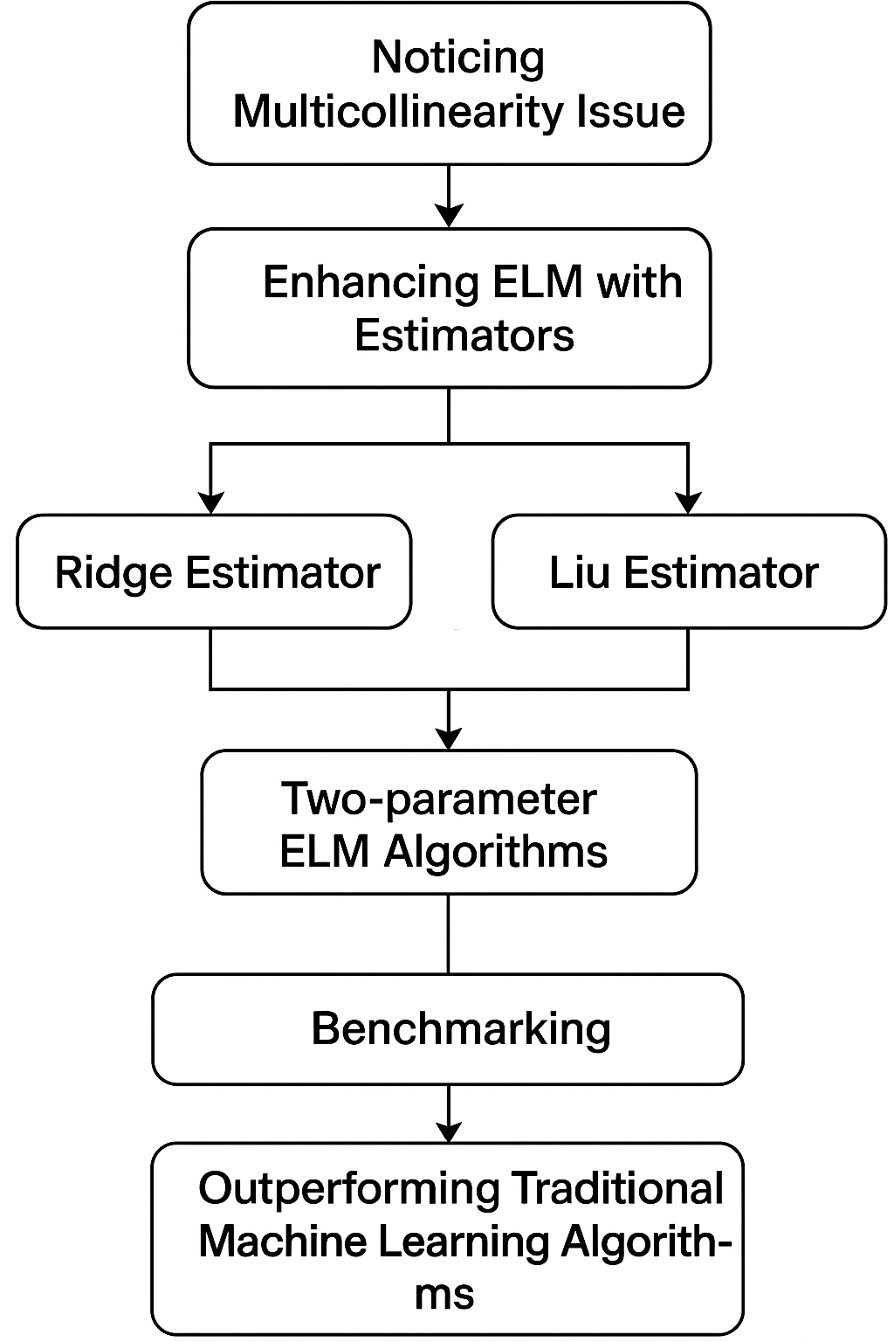.

Module Description
- Data Loader Module: Responsible for loading diverse datasets for testing.
- Multicollinearity Analyzer Module: A diagnostic tool to detect and quantify multicollinearity.
- ELM Algorithms Module: The core library containing the novel TP1-ELM and TP2-ELM implementations.
- Performance Evaluator Module: A standardized set of functions to test and compare different machine learning models.

Hardware and Software Requirements
Hardware Requirements:
- Processor: A modern CPU i5 is sufficient, as ELM is computationally efficient.
- RAM: A minimum of 8 GB of RAM is needed to handle typical datasets.
Software Requirements:
- Operating System: Windows, macOS, or Linux.
- Programming Language: Python.
- Libraries and Frameworks:
  - Data Science: NumPy for numerical operations, Pandas for data handling.
  - Machine Learning: Scikit-learn for baseline model comparison.
  - Visualization: Matplotlib for plotting results.

